Karst and Caves of Micronesia:
A state-of-knowledge review

Elery Hamilton-Smith
IUCN / WCPA Task Force on Caves and Karst

V 1.0
2007

Natural Arch, Palau. | 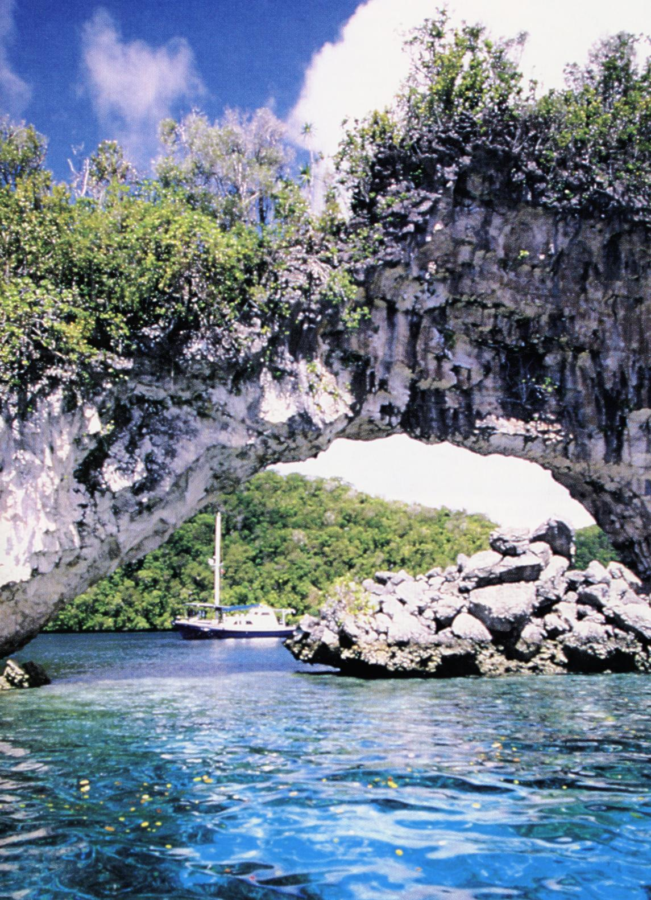

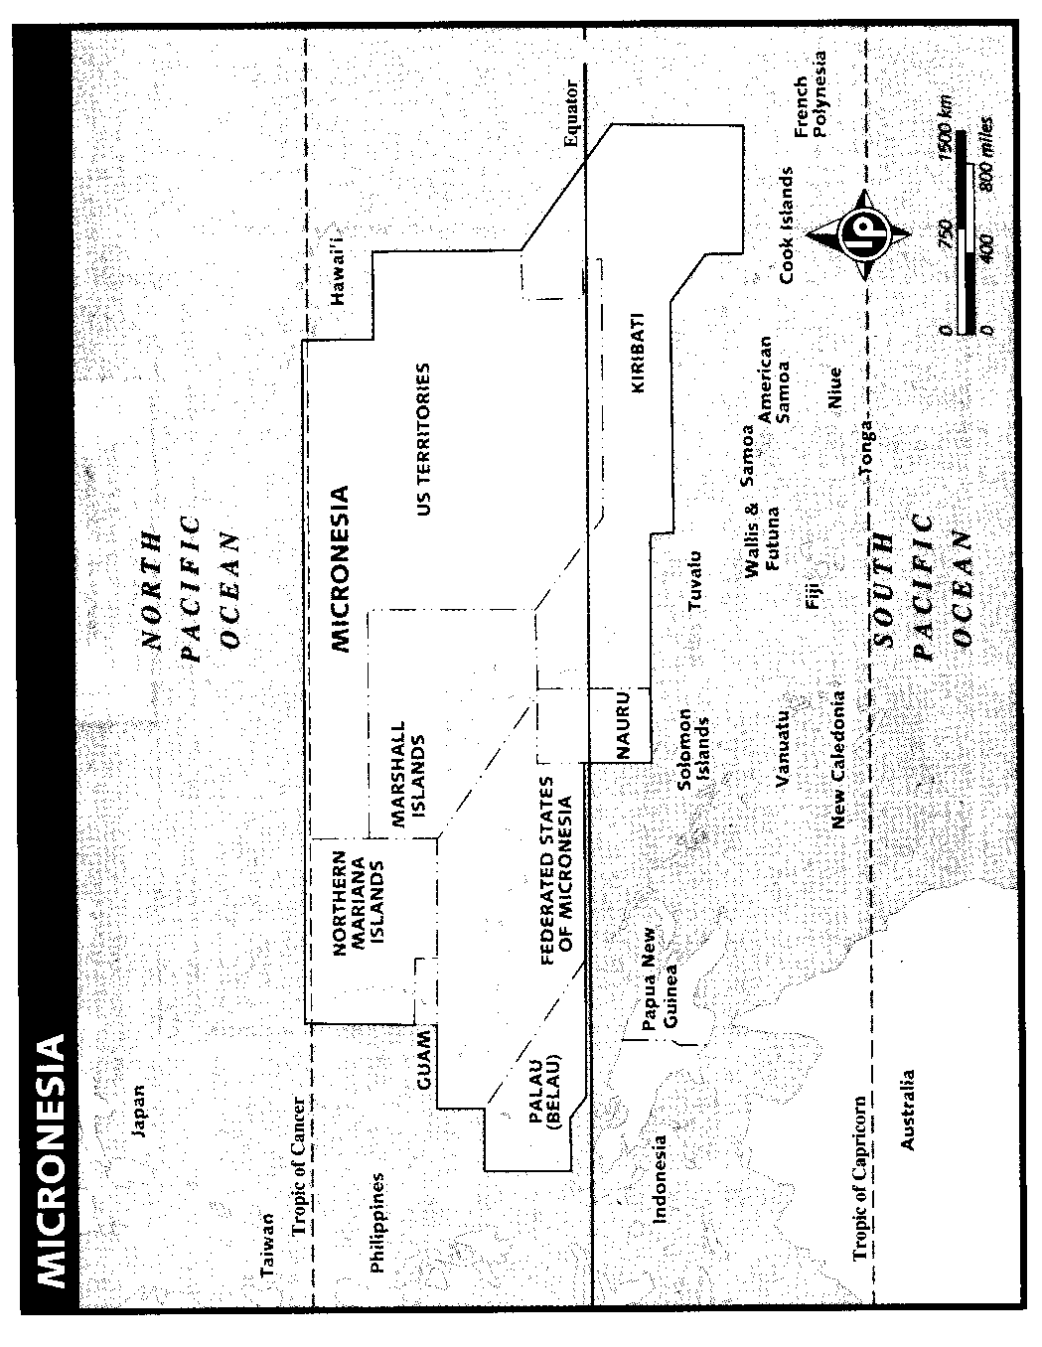

This document must be considered as a first draft only. Corrections or Updates will be welcome, and further versions will be made available in due course.

Contents

Introduction 3

Summarising Recent Research 4

Guam 6

Northern Marianas 7

Federated States of Micronesia 8

Palau 10

Other nations 12
- Marshall Islands
- Kiribati
- Nauru

References 13

Introduction

The Mariana islands, on the western side of Micronesia, are a series of high volcanic Islands on the Western Mariana islands running more-or-less parallel with the Mariana trench. This is the deepest ocean trench, being some 11 km in depth and running for almost 3,000 km. Other islands throughout the region may be volcanic, volcanic with a limestone cap, or carbonate karst.

Micronesia has now become an important site for research on the origin and evolution of carbonate islands. Many of these are atolls, which in the strict sense of the term are circular or irregular islands, each surrounding a central lagoon. They each originated as a fringing reef surrounding a volcanic island, then as the sea level dropped, so the volcanic island was submerged. In Micronesia, many are discontinuous and so form an extended ring of small, narrow islands. Atolls are commonly karstified, but a number of those in Micronesia are very low and so have only very limited karst.

However, in due course, the central lagoon may become filled with broken limestone and soil and is then more properly referred to as coral island. The raised edge often remains, and has often been termed the Makatea (from the Polynesian). Then in the Pacific region, tectonic change may cause the seabed (and the volcanoes upon it) to rise, and so an atoll may achieve a significantly high level above the ocean. When this occurs the characteristic atoll landform may even be disguised by tectonic change.

One of the problems in discussing caves of the region is that there are a remarkable number of artificial tunnels, mainly constructed during times of war, and particularly in World War II. However, the local residents have often referred to these as caves, and it may be difficult without an actual visit to determine which of the reported sites are natural and which are artificial.

The need for review and development of protected area status or even international recognition through further World Heritage inscription was recorded at the 2001 Mulu Forum on Karst sites of the Asia-Pacific Region. In the subsequent assignation of responsibility for follow-up from the forum, I was asked to watch over the Oceania region. This document is one step in that process.

It must be recognised on one hand that the culture of the Pacific nations has given very considerable recognition to principles of conservation in resource management, but on the other hand, modernisation and tourism bring a new series of threatening processes to the region. Commercial activity has certainly also led to invasive species of both animals and plants which may damage or even destroy important parts of the eco-system

Summarising recent research

The genesis and evolution of carbonate islands has been studied over some years. Mylroie and his colleagues, working in the Caribbean, developed a Carbonate Island Karst Model (CKIM), best summarised by Mylroie & Vacher (1999). Studies in Micronesia were set up to further test this model and to examine the influence of compounding characteristics.

The complex structure of Guam as an island provided an excellent research site, as it includes both a typical carbonate island form in the North and a more continental structure in the South. The abstract from Mylroie et al. (2001) follows:

. . .This paper describes the karst of Guam in terms of the Carbonate Island Karst Model (CIKM), a general model for the unique karst carbonate islands. The CIKM recognizes several processes and conditions unique to carbonate islands: 1) enhanced dissolution at the surface, base, and margin of the fresh-water lens; 2) the history of both vertical migration and stable positioning of these zones according to
glacioeustatic and tectonic changes in relative sea level; 3) the size of the island's catchment area relative to its perimeter, which can vary with sea level change; 4) the hydrologic implications of the unique eogenetic environment of their young limestones; and 5) the position of the island's carbonate-basement contact relative to sea level and the island surface over time.

Guam's complex depositional and tectonic histories have endowed it with a unique legacy of karst features. The northern half is a Pleistocene karst plateau in Plio-Pleistocene limestone units that exhibit all the characteristic karst features of carbonate islands, from the simplest to the most complex. The epikarst is similar to that on other carbonate islands. Most closed depressions are broad and shallow; probably reflecting original depositional morphology, although vertical-walled collapse and banana-hole type features are also present. Caves include a few pit caves, some of which are very deep. Traversable stream caves occur where the limestone-basement contact is exposed on the flanks of volcanic outcrops. The most abundant caves are flank margin caves, which can be found all along the modern coast, and which occupy distinct horizons in the faces of the cliff line surrounding the plateau. Discharge features have been documented for three types of coastline around the northern plateau: (1) deeply scalloped embayments with broad beaches; (2) linear beaches fronted by fringing reefs; and (3) sheer cliffs with narrow or no benches, and only occasional small reefs. In the embayments, karst groundwater discharges by dif-
fuse flow from numerous seep fields and as concentrated flow from springs along the beach. Seeps are found along the linear beaches, but we have not noted significant flow from springs or coastal caves. Along the cliff-dominated coast, karst groundwaters discharge in spectacular flows from dissolution-widened fractures, coastal caves, and submarine vents, most notably along the northwest coast.

The southern half of Guam is an uplifted volcanic highland containing a karst terrain on Mio-Pliocene limestone remnants in the interior. Because these units lie above the influence of the fresh water lens, sea water mixing, and sea level change, the karst is a classic tropical continental karst, with features that include contact springs issuing from well-developed caves, sinking streams with resurgences, and conical cockpit karst. Along the southeast coast, which is flanked by a continuous uplifted Pleistocene limestone unit, antecedent streams draining the interior have incised deep canyons. Dry valleys and large closed depressions in this unit appear to be associated with allogenic waters originating in the interior.

Taborosi (1999) and Taborosi et al. 2003 both provide further detail and discussion of this work, while Taborosi (2004, see below under Guam) describes the karst of Guam in more detail.

Sinian in the Northern Marianas, on the other hand, is simply a typical Carbonate Island Karst. Again, I quote the abstract from Stafford et al.(2005):

. . . Tinian, located in the western Pacific Ocean, is an Eocene volcanic edifice mantled by younger algal and coralline limestones. Carbonate rocks are eogenetic, producing an island karst terrane as predicted by the Carbonate Island Karst Model. Surface karst features include epikarst, closed depressions, and freshwater discharge sites. Subsurface karst features include three morphologically distinct cave types:
mixing zone, fissure, and contact. Controls on cave development inferred from morphology are supported by non-parametric statistical analysis. Mixing zone cave development is controlled by freshwater lens position, fissure cave development is controlled by structural deformation, and contact cave development is controlled by lithologic boundaries. Horizons of mixing zone caves preserve at least three previous sea level positions, but differential rates of uplift between fault blocks prevent correlation of horizons across the entire island. Tinian karst development demonstrates the functionality of the Carbonate Island Karst Model and illustrates how portions of individual islands may exhibit each of the ideal island categories to some extent.

Stafford et al (2004/5) have examined this process further in their work on Aguijan which is almost certainly rests upon a basement of ash and breccia. Along with other islands in the Marianas, it has a complex geological history, and the largest cave is quite a-typical. It does not conform to the normal pattern seen on other coral islands, and indicates the need for further study and conceptualisation of the hydrology in these islands.

Taborosi and Hirakawa (2003) demonstrated that although the simple basic phenomenon of tufa stalactites developing in a light-oriented way as a result of algae or other biota on the surface of the minerals is valid, there is an immense range of variation in the details of both tufa structures and process. They identified the general presence of bacteria, cyanobacteria, eukaryotic algae, fungi, bryophytes, higher plants and invertebrates. However, in the splash zone of the seawater, they found a much greater diversity of biota, although both bryophytes and higher plants were absent. Their paper is probably the best overview of this phenomenon yet published and like the other papers discussed here, has an exhaustive bibliography.

Guam

Rogers and Legge (1992e) provide a useful outline of the geological history of Guam, commencing with volcanic events in the later Eocene. These continued until the late Miocene, probably some 12 million years ago, but were interspersed with various periods of early limestone deposition. After the vulcanism ceased, deposition of further limestones has continued, but these have been interrupted and fragmented by tectonic changes in the elevation of the island. Thus, the geology has been indeed complex and might even be described as tumultuous.

The discussion above on recent research (Mylroie et al. 2001) outlines current understandings of the genesis and evolution of the karst and caves. Because of its high porosity, karstic solution tends to be concentrated at points where dissolution has been focussed. In the vadose zone, this is generally due to geologic boundaries at points of structural discontinuity such as lithological boundaries. Sometimes this leads to shafts that provide for sinking waters. In Guam, these are generally between limestones and the underlying volcanic rocks, particularly on mountain slopes. In the phreatic zone, mixing corrosion is probably the most significant form of dissolution.

Taborosi (2004) provides both an excellent analysis of the current state of the karst, with many fine photographic illustrations, and a guide for the inquiring and adventurous visitor. It also provides detailed instructions for finding each of the major caves and a series of excellent maps. Few karst areas would have such an excellent and well-presented manual.

The recorded cave fauna includes several species of Crustacea and a declining population of cave swiftlets. The only cave-dwelling bat reported was Emballonura semicaudata, but this is now thought to be extinct.

The Chamorro people left both Pictographs and pottery in some of the caves over many years. However, most human relics in the caves are left over from World War II.

.

.

Northern Marianas

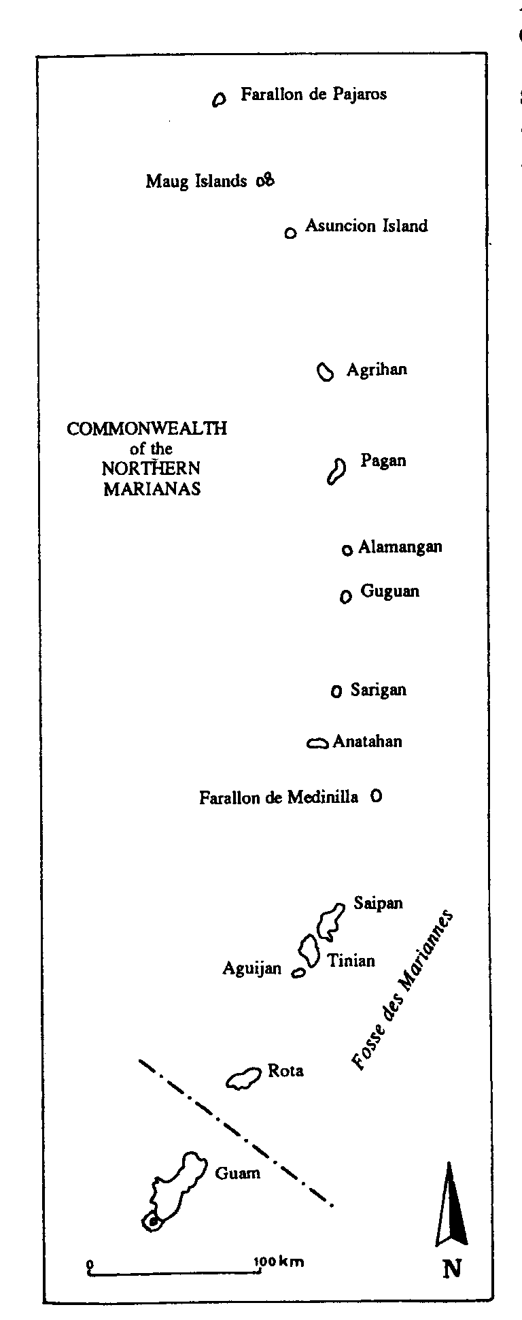 | The archipelago has both extensive areas of karst, particularly on Saipan, and numerous lava tubes, particularly on Pagan as a result of the 1925 eruption of Mt. Pagan. Rogers and Legge (1992a, 1992b) provide a summary of the geological history, while Stafford et al (2005) describe the speleogenesis of karst and cave development on Tinian. Both are remarkably similar to the patterns described for Guam.  Rogers and Legge provide a preliminary list of some 80 caves on Saipan (1992b) and 27 on Rota (1992d). In each case, there are relatively few large caves, but many small ones. The large caves all have many World War II relics and some caves have suffered considerable damage from this period. Rogers (1991) also discussed the many lava tubes.  Again, the identified cave fauna includes Crustacea and Cave Swiftlets. Emballonura semicaudata is said to have once been abundant, but is now generally regard as extinct. However, Rogers (1991) reported large numbers of cave-dwelling bats, but provided no details.

.

Federated States of Micronesia

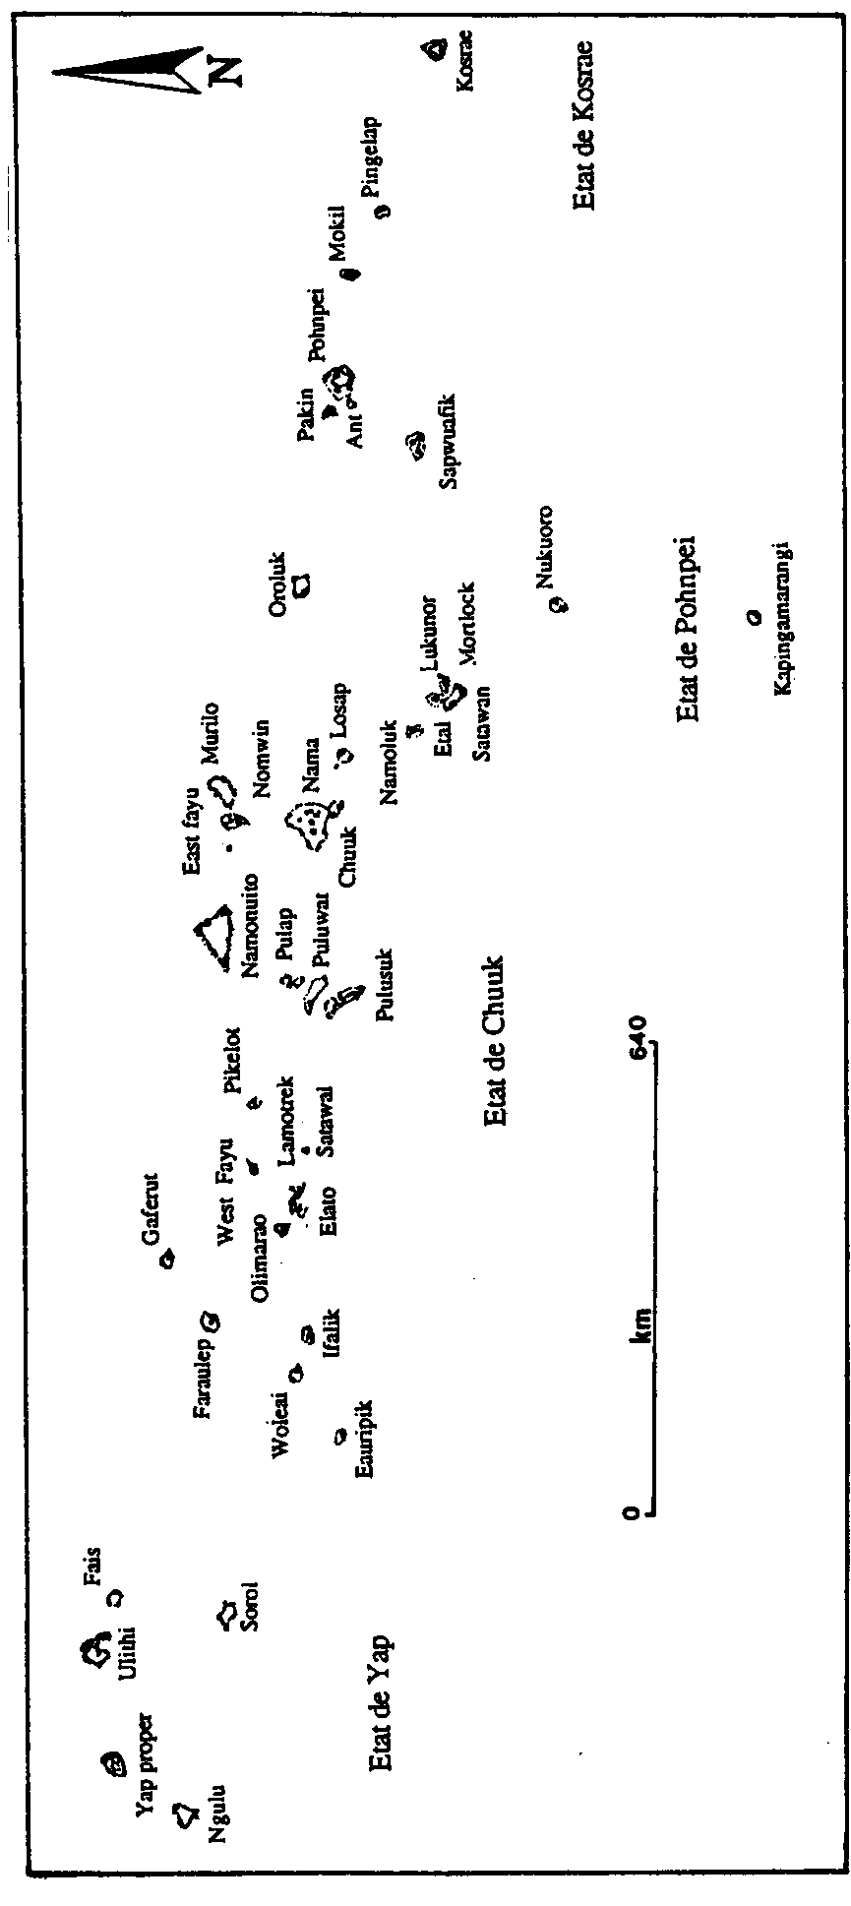

A series of some 37 major atolls or islands, many of which include various arrangements of smaller islets. Probably the most remarkable is Chuuk (formerly Truk) which consists of a relatively large atoll with many smaller islets within its central lagoon.

Rogers and Legge (1992a) again provided a useful description of the geological history of these islands. They are of much more recent and less complex origin than the Marianas group. Rogers (1991) and Rogers and Legge (1992c) reported both overhang caves and talus caves in the volcanic rocks of Pohn Pei, many of which are decorated with pictographs and seen by the residents as important sacred places.

They also reported lava tubes on both Kosrae and Chuuk and sea caves in the volcanic coasts of the Yap Group. There are many atolls, generally of a relatively low elevation. At this stage, I have not been able to find descriptions or records of caves or other karstification.

There appear to still be be healthy populations of three subspecies of cave swiftlets (Browning 1993) and the bat Emballonura semicaudata. The best-known site is Bird Cave on Kosrae.

The immense ruins of early cities and other evidence of a complex and well-developed cultural life are a remarkable feature of these islands. There are a large number of languages and high levels of skill in the arts.

The people of Yap used large discs of limestone as money. These were up to 4-5 metres in diameter and weighed as much as nine tonnes. They were quarried from massive speleothems in Palau, some 400 km. distant form their final home in Yap. Although it has been claimed that the stone from which the disks were made was aragonite, petrographic analysis shows that the dominant mineral is calcite with very little or no aragonite. (Fitzpatrick 2003)

Palau

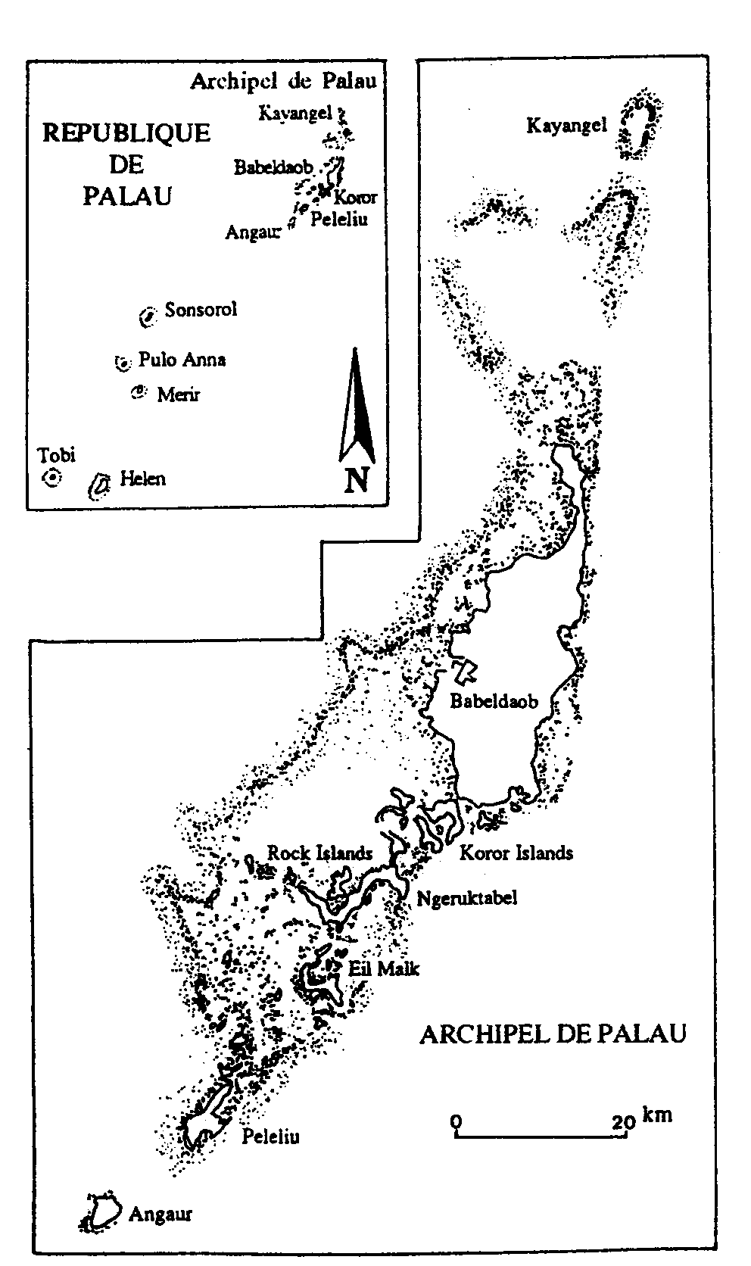 | The Palau archipelago is located at the Western extremity of the Federated States of Micronesia, but is governed independently. There are extensive areas of karst, with a large number of caves, at least a number of which are large and well decorated with rich deposits of calcite. The biodiversity and geodiversity of the islands are indeed rich and the scenery is strikingly beautiful  Rogers and Legge (1992c) described the geological history, which is very similar to that of the Marianas and Guam. There has been an extremely complex sequence of volcanic events, limestone deposition and tectonic changes in elevation.  Babeldaop, Arakabesan, Malakal and Western Koror are all high volcanic islands, with dense forest vegetation. The South-east of Babeldaop, Airai, Ngerutabel and  Eil Maik, the northern parts of Peleliu and Angaur, and Eastern Koror are all high limestone islands, again with dense forest and often a series of inland lakes.

As described above, many are compound islands with a mix of volcanic and limestone rocks: Southern Babeldaop, Koror, Ulebsechel, Peleliu, Anguar, Ngerchou and Ngedbus. Finally, there are the low atolls, including Kayangel, Helen Reef, the Tobi Islands and the Ngemelis Group.

The Rock Islands are a very distinctive and particularly attractive group of some 200 islets. They are small and generally round, but are undercut by solution notches on all sides. These may range from one metre above mean sea level to as much as 9 metres in elevation. They have a rich forest cover, and are sometimes said to look like “emerald mushrooms rising from a turquoise-blue sea” (Lonely Planet Guide).

Along with the richness of the vegetation cover, the relatively high rainfall has led to the development of a wide range of karren surfaces on the limestone, which adds to the difficulty of walking through the vegetation. The various elements of the environment have come together and produced a rich and extremely diverse mineralisation of the surface limestone. There are an unknown number (but very many) caves, and these are highly decorated with speleothems, as are the solution notches on the Rock Islands. The abundant biota has also led to rich and complex mineral deposits (primarily phosphates) in the caves and between the surface karren pinnacles.

There are many lakes, include those on many of the small Rock Islands. Some are referred to as cenotes, but given the lack of any significant investigation of their origins, the accuracy of using this name is unknown. Eil Malk probably has the most interesting, with Palau’s largest salt lake, a hot water lake (37º) and a meromictic lake containing plankton, hydrogen sulphide and other gases. Most of the lakes also support a diversity of biota, but there does not appear to have been a systematic review of this fauna as yet.

Osborne (1966) and Fitzpatrick (2003) have described the quarrying of flowstone by the people of Yap (see above) who used it to make their stone money. Some incomplete “coins” remain in place. The caves are rich in deposits of archaeological materials and cultural artefacts.

Little is known of the cave fauna. A number of species of aquatic Crustacea have been described; some caves have rich populations of cave swiftlets and of the bat Emballonura semicaudata; there are various reports of terrestrial invertebrates being seen in the cave, but none of these have been identified.

However, in summary, the available evidence is that Palau has the most important and significant features from the perspectives of biology, geology, geomorphology, archaeology, anthropology, mineralogy and probably some other fields of any Micronesian country.

Other Nations:
Marshall Islands, Kiribati and Nauru

The three remaining nations do not appear to have significant karst or caves.

The Marshall Islands are generally very low atolls, and land itself is often extremely narrow. A detailed description is available in the World Heritage Tentative Listing prepared by the Alele Museum (2005).

Kiribati comprises some 30 atolls, virtually all of which are low-lying atolls. Banaba is the only other island and, like Nauru, has been devastated by phosphate mining.

Nauru is famous for its almost complete removal of the land as phosphate, leaving behind the formerly buried karren pinnacles as an eerie landscape.

References

General

Galbraith, K., G. Bendure & N. Friary (eds.) 2000. Micronesia. Lonely Planet Publications, Melbourne.

Earth Sciences

Mylroie, J.E., J.W. Jenson, D.Taborosi, J.M.U. Jocson & C. Wexel (2001) Karst Features of Guam in terms of a general model of Carbonate Island Karst. Journal of Cave and Karst Studies, 63(1): 9-22.

Mylroie, J.E. & Vacher, H.L. (1999) A conceptual view of carbonate island karst, in
Palmer, A.N., Palmer, A.V. & Sasowsky, I.D. (eds.) Karst Modelling. Karst Waters Institute Special Publication #5: 48-58.

Rogers, Bruce W. (1991) Vulcanospeleological pseudokarst in Micronesia – an Overview. Proceedings of the 6th International Symposium on Vulcanospeleology, Hawaii, pp. 163-167.

Rogers, Bruce W. and Charmian J. Legge (1992a) Karst Features of Pohn Pei, Chuuk and Wagab, Federated States of Micronesia. Pacific Basin Speleological Survey, Bulletin #1, 10 pp.

Rogers, Bruce W. and Charmian J. Legge (1992b) Karst Features of Saipan, Commonwealth of the Northern Mariana Islands. Pacific Basin Speleological Survey, Bulletin #2, 26 pp.

Rogers, Bruce W. and Charmian J. Legge (1992c) Karst Features of the Palau Islands. Pacific Basin Speleological Survey, Bulletin #3, 133 pp.

Rogers, Bruce W. and Charmian J. Legge (1992d) Karst Features of Rota (Luta) Island, Commonwealth of the Northern Mariana Islands. Pacific Basin Speleological Survey, Bulletin 4, 20 pp.

Rogers, Bruce W. and Charmian J. Legge (1992e) Karst Features of Guam. Pacific Basin Speleological Survey, Bulletin 5, 33 pp.

Stafford, K., J. Mylroie, D. Taborosi & J. Jenson (2004/5) Eogenetic karst development on a small, tectonically active, carbonate island: Aguijan, Mariana Islands. Cave and Karst Science, 31 (3) : 101-108.

Stafford, K., J. Mylroie, D. Taborosi, J. Jenson & J. Mylroie (2005) Karst development on Tinian, Commonwealth of the Northern Mariana Islands: Controls on dissolution in relation to the carbonate island karst model. Journal of Cave and Karst Studies, 67(1): 14-27.

Taborosi, D. (1999) Karst inventory of the northern Guam lens aquifer. In Palmer, A.N., M.V.Palmer & I.D. Sasowsky (eds.) Karst Modelling. Karst Waters Institute Special Publication 5: 244.

Taborosi, D., J.W. Jenson & J.E.Mylroie (2003) Zones of enhanced dissolution and associated cave morphology in an uplifted carbonate island karst aquifer, Northern Guam, Mariana Islands. Speleogenesis and Evolution of Karst Aquifers, 1(4). www.speleogenesis.info 16 pp.

Taborosi, D. 2004. Field Guide to the Caves and Karst of Guam. Bess Press, Honolulu.

Taborosi, D. & Hirakawa, K. (2004) Biota and Biological Processes associated with sub-aerial tufa stalactites in the tropics. Cave and Karst Science, 31(2): 51-62.

Biodiversity

Browning, M.R. (1993) Species limits of the cave swiftlets (Collocalia) in Micronesia. Avocetta, 17: 61-68.

Flannery, T. (1995). Mammals of the South-West Pacific and Moluccan Islands. Cornell University Press, New York.

Hutson, A.M., Mickleburgh, S.P. & Racey, P.A. (comp.) (2001) Microchiropteran Bats: global status survey and conservation action plan. IUCN/SSC Chiroptera Specialist Group, IUCN, Gland, Switzerland and Cambridge, UK.

Juberthie, C & Decu, V. (eds) (1996). Encyclopaedia Biospelologica: Vol III. Sociètè Internationale de Biospèologie, Moulis, France.

Archaeological / Historic

Fitzpatrick, S., 2003. An archaeological study on the extraction of limestone from caves and rockshelters for producing stone money in Western Micronesia. Cave and Karst Science, 30(2): 75-82.

Osborne, D. 1966. The Archaeology of the Palau Islands, Bishop Museum Bulletin 230, 497 pp.

Bibliographic Resources
Bulletin Bibliographique Spéléologique, published by the Swiss Speleological Society. Files for 1988-2004 are currently available as both hard copy and on searchable CD-Rom and future issues will appear in these formats.

